# Lab 3b: CSS fonts and forms

# Prepare your project:

* Download the provided starter code.
* Add a css/css-reset.css stylesheet to your project(create an empty CSS file, then use the extension ctrl+alt+r, on MacOS: cmd+alt+r). Add the reference to this file from all your future HTML files. These CSS rules will cancel all browser default styles.
* To have a clean html file, create your CSS rules in the external file css/styles.css, notice the link tag in the head section:

<link rel=”stylesheet” href=”css/styles.css”>

# Style the form:

Open the provided form (register.html). Then, apply the rules that are shown in the example below:

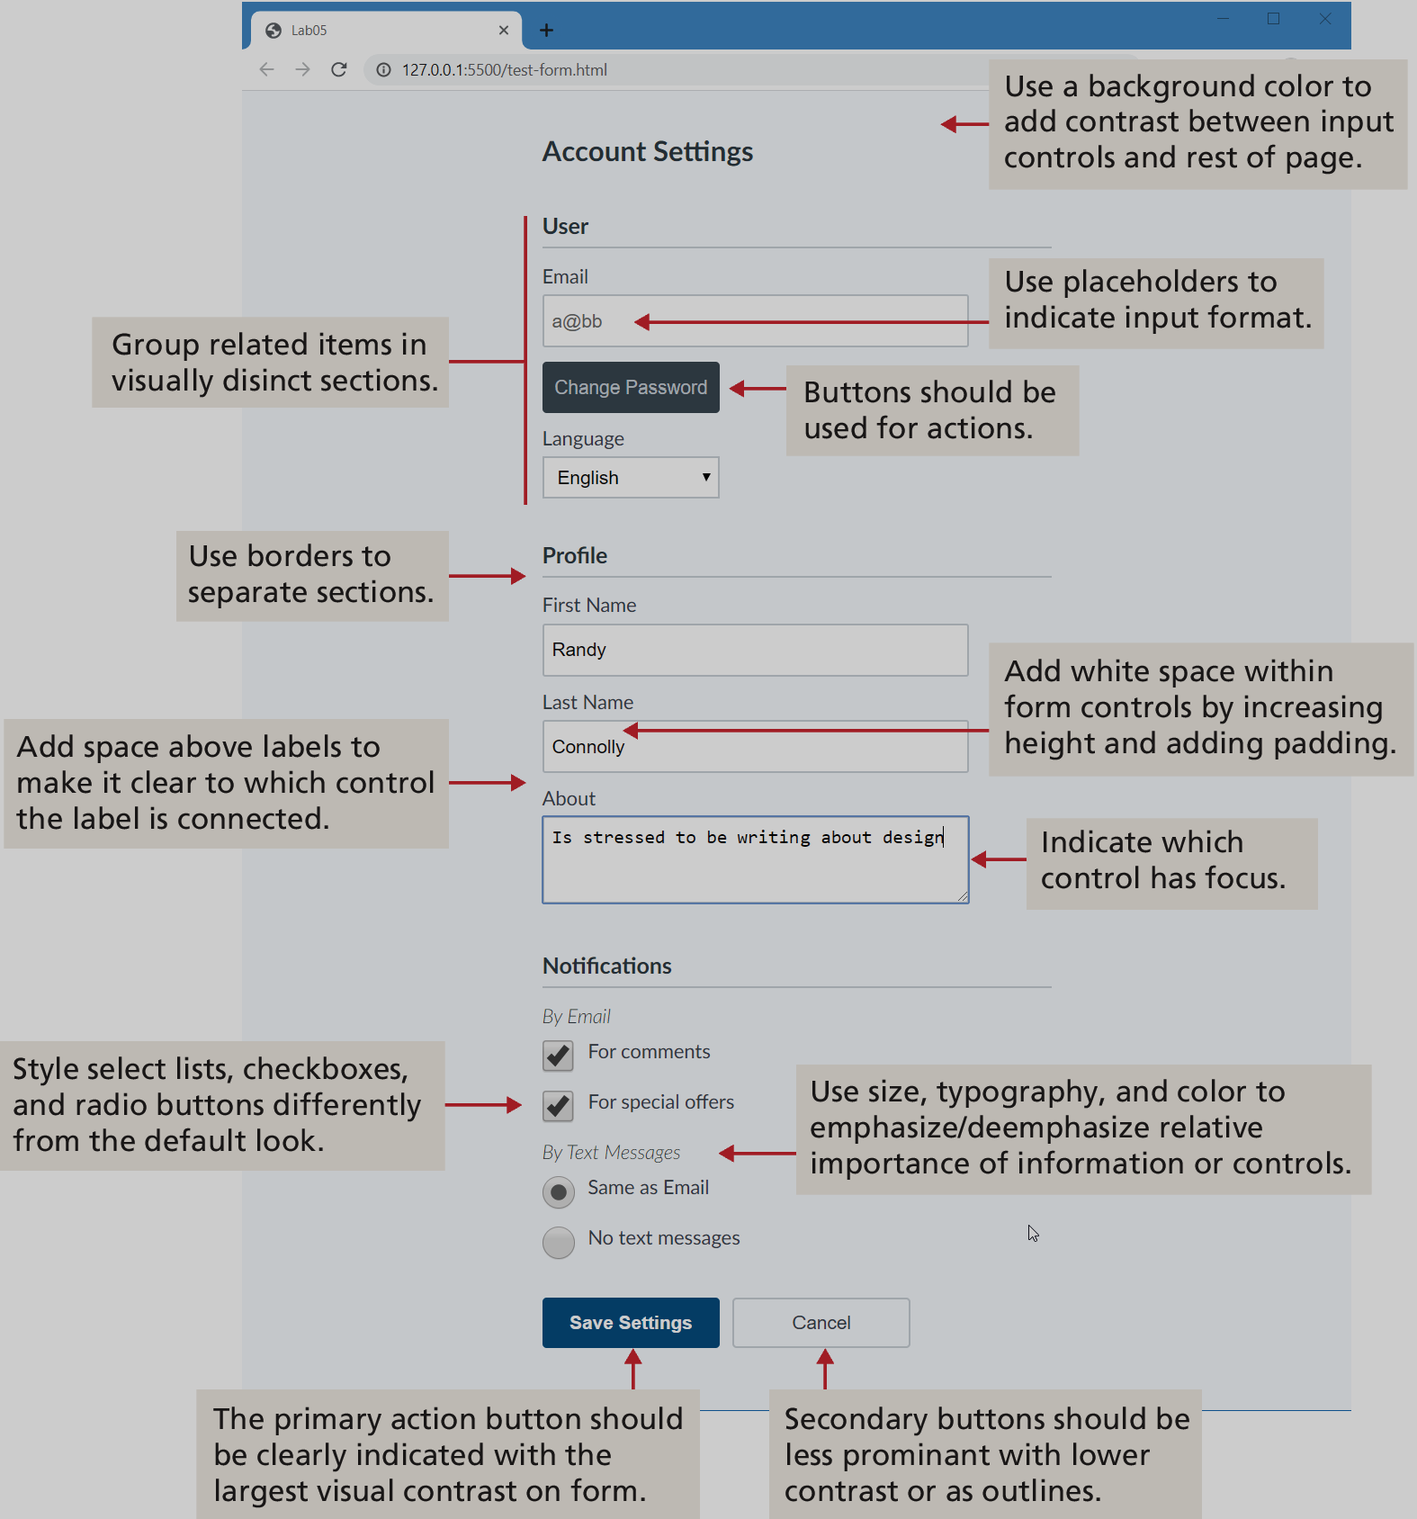

# Font CSS rules:

1. Add a font-size property for each of your elements: 20px for all text in your page, 24px for the header elements, and 16px for the rest of the elements.
2. Choose a font-family for your page with at least on generic font as fall back strategy. Use a web font from google font or fontsquirrel.
3. Add a text-transform property to your header to make it uppercase.